Section 1: Workflow Audit Table
No. | Weekly Task | Classification | Rationale
1 | Attend university classes | Just Me | AI cannot attend classes, participate in discussions, or interact with instructors on my behalf.
2 | Take quizzes, lab exams, and final examinations | Just Me | I must complete assessments myself to demonstrate my own knowledge and skills.
3 | Study lecture materials and prepare for exams | Collaborate with AI | AI explains difficult concepts, creates summaries, and generates practice questions, while I do the learning and revision.
4 | Complete programming assignments | Collaborate with AI | AI helps debug code, explain errors, and suggest improvements, but I write, test, and submit the final solution.
5 | Write lab reports | Collaborate with AI | AI provides report templates and formatting suggestions, while I perform the experiment, write the report, and attach screenshots manually.
6 | Research AI, programming, and software development topics | Collaborate with AI | Whenever I need information about a topic or have questions, I ask AI for explanations and examples. AI helps me learn faster, while I verify the information and build my own understanding.
7 | Develop and improve the SEU Routine Maker web application | Collaborate with AI | I create the ideas and features for the application. AI helps implement, debug, optimize, and improve the code while I make all final technical decisions.
8 | Develop personal projects (e.g., LocationKhuji) | Collaborate with AI | I design the project and decide the features. AI assists with coding, debugging, and implementation while I build and verify the final product.
9 | Participate in 6-hour AI hackathon challenges | Collaborate with AI | I create the project idea and solution strategy. AI helps with coding, debugging, and rapid implementation so I can finish within the time limit.
10 | Search and summarize research papers or technical documentation | Delegate to AI with Review | AI quickly summarizes technical resources, but I review the information and verify important details before using them.
11 | Write LinkedIn posts, emails, and project documentation | Delegate to AI with Review | AI creates the first draft, and I edit the content to match my own style before publishing or sending.
12 | Improve grammar, rewrite, or translate documents | Delegate to AI with Review | AI rewrites, corrects grammar, or translates my writing, and I review the final version to ensure it matches my intended meaning before using it.
13 | Plan my weekly study and project schedule | Fully Automate | AI can organize my study and project schedule with minimal manual adjustments.
14 | Present projects or defend my work | Just Me | I must explain my own work, answer questions, and demonstrate my understanding during presentations or evaluations.
15 | Decide project goals, career plans, and final feature priorities | Just Me | These decisions depend on my personal vision, interests, and long-term career goals, so I make the final decisions myself.
Classification Summary
Classification | Tasks
Just Me | Attend university classes; take quizzes, lab exams, and final examinations; Present projects or defend my work; Decide project goals, career plans, and final feature priorities.
Collaborate with AI | Study lecture materials and prepare for exams; Complete programming assignments; Write lab reports; Research AI, programming, and software development topics; Develop and improve the SEU Routine Maker web application; Develop personal projects (e.g., LocationKhuji, SchedOS); Participate in 6-hour AI hackathon challenges.
Delegate to AI with Review | Search and summarize research papers or technical documentation; Write LinkedIn posts, emails, and project documentation; Improve grammar, rewrite, or translate documents.
Fully Automate | Plan my weekly study and project schedule.

Section 2: Three Target Tasks with Measurable Success Definitions (FL-02 to FL-04)
From the 15 audited recurring tasks, the following three high-leverage tasks are selected to be reused and systematically improved throughout modules FL-02, FL-03, and FL-04:
Target Task # | Audited Task | Classification | Measurable Success Definition ("What Done Well Means")
Target Task 1  (Coding & Development) | Task 4 & 7: Complete programming assignments & develop web applications (e.g., SEU Routine Maker, LocationKhuji) | Collaborate with AI | 1. Functional Integrity: Code compiles, passes all unit tests, and introduces zero unvetted security or logical bugs.  2. Conceptual Ownership: I can independently explain, defend, and refactor every generated function during code review without consulting AI.  3. Measurable Speedup: Reduces boilerplate scaffolding and syntax debugging time by at least 40% while maintaining strict clean-code standards.
Target Task 2  (Literature & Research) | Task 10: Search, digest, and summarize research papers or technical documentation | Delegate to AI with Review | 1. 100% Factual Fidelity: Extracts core problem, mathematical formulations, baseline metrics, and limitations with zero hallucination (verified against source PDF).  2. Standardized Brief: Produces a 1-page structured brief (Objective, Method, Benchmark Result, Actionable Takeaways).  3. Ingestion Velocity: Reduces literature comprehension time from 45 minutes down to 15 minutes per paper.
Target Task 3  (Technical Writing & Comms) | Task 11: Write project documentation, README files, and professional LinkedIn posts | Delegate to AI with Review | 1. Authentic Tone: Requires <20% manual editing to eliminate generic AI fluff ("delve", "game-changer", "tapestry") and preserve my natural technical voice.  2. Self-Contained Clarity: Readers with zero prior context can follow setup instructions or understand project milestones in under 2 minutes.  3. Publication Velocity: Produces a publication-ready first draft within 10 minutes.

Section 3: Tool Setup & Project Configuration Evidence
Toolkit Verification Status:
• Claude.ai Account (Free Tier): Active — Configured with Custom Project.
• ChatGPT Account (GO): Active — Available for answering question and genarate figure.
• Google AI Pro: Active — Available for Coding and comparative testing.
• Anthropic Academy Account: Active — Enrolled in "AI Fluency: Framework and Foundations" (Module 1 completed).

Claude Project Configuration & Custom Instructions
Project Name: Fardin's Learning & Engineering Hub
Custom Instructions Configured in Claude:
----------------------------------------------------------------------
[Who I am]
I am Md. Fardin Hossain, a Computer Science student and Machine Learning intern at FlyRank. I develop web applications and ML systems (e.g., SEU Routine Maker, LocationKhuji).
[Tone & Style Preferences]
- Direct, concise, and technically rigorous.
- No conversational filler, no sycophantic praise, no generic AI buzzwords ("delve", "testament", "tapestry").
- Focus on first-principles reasoning, edge-case analysis, and production-ready code.
- Always be honest about limitations and uncertainty.
[Current Goals]
- Build and deploy state-of-the-art machine learning models on real-world search intelligence datasets.
- Prepare high-quality academic research papers and technical documentation.
- Streamline my development and study workflows using effective human-AI collaboration.
----------------------------------------------------------------------
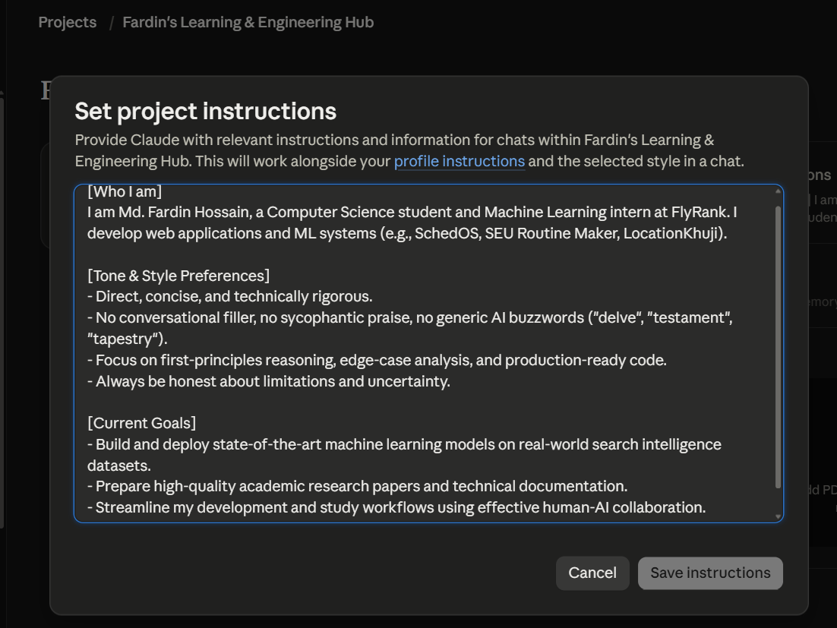

Anthropic Academy Course Enrollment & Module 1 Evidence
Course: AI Fluency: Framework & Foundations (Anthropic Academy)
Status: Enrolled & Module 1 ("Course Introduction & The AI Fluency Framework") Completed.
